User Manual for Online e-Consignment Declaration (Dtd 05/01/2010)

1. What is a Declaration?
A declaration is a self attested consolidated details of goods contained in a transporting vehicle..

2. What is an e-Consignment Declaration?
The process of capturing the goods details for a particular vehicle, well before, it reaches the Kerala State Boundaries using the KVATIS online e-consignment Declaration (Link available in the official website of Kerala Commercial Taxes Department).

3. Who are all filing e-Declaration?
Any consignor / consignee / transporter has the facility to declare the details of consignment in advance, while the goods are loaded in the vehicle. All users can directly login without username and password.

4. How to file e-Return?
Dealers having an internet connection can do online e-Consignment Declaration. Open any browser (like Internet Explorer, Mozilla Firefox etc) and type www.keralataxes.gov.in in the address column.

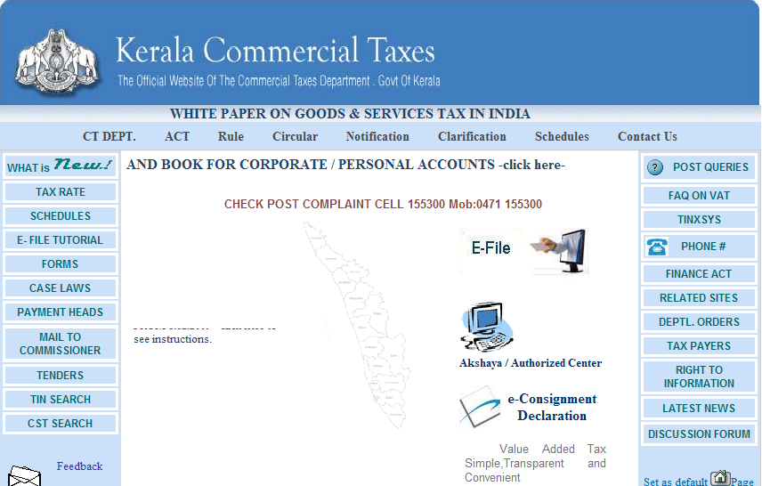

Click e-Consignment Declaration link. All Unregistered dealers can directly login without username and password. The following screen appears.

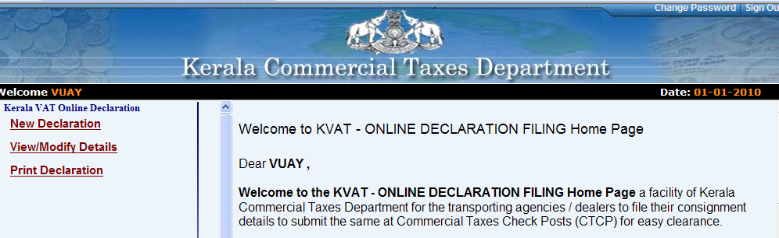

Use the following links,

- New Declaration to enter new goods declaration

- View / Modify Details to modify the declaration already entered.

- Print Declaration to print the e-Consignment Declaration

- Latest Instructions latest information on e-Consignment Declaration.

- Download User Manual user manual on e-Consignment Declaration

- Download Commodity Group List list of all the 7800 commodities linked to its corresponding commodity group (total 320 commodity groups).

- Contact Details Telephone numbers / email ids of Kerala Commercial Taxes Department help lines.
The detailed procedures are as follows.

1. New Declaration

The following screen appears on clicking the link New Declaration.

Enter the vehicle details of the consignment.

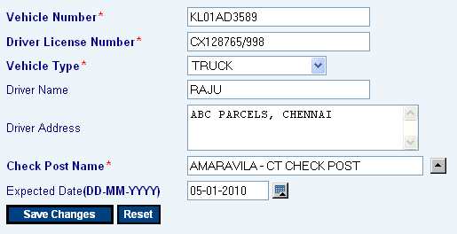

1 | Vehicle Number | This is an entry field. Enter the Vehicle Number.
2 | Driver License Number | This is an entry field. Enter the License Number of the driver.
3 | Vehicle Type | This is a selection field. Select the type of vehicle from the list (like lorry, truck etc).
4 | Driver Name | This is an entry field. Enter the Name of the driver.
5 | Driver Address | This is an entry field. Enter the Address of the driver.
6 | Expected CheckPost | This is an entry / selection field. Enter the expected date of vehicle arrival at CheckPost in dd/mm/yyyy format or select from the calendar.
7 | Expected Date at CheckPost | This is a selection field. Select the checkpost name from the list.

On saving, system navigates to the Consignment and Commodity Details.

Enter the Consignment Details.

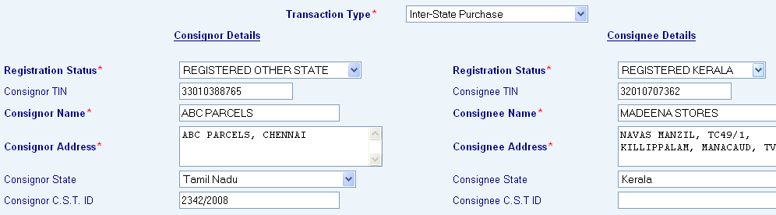

Transaction Type

1 | Transaction Type | This is a selection field. Select from the list (Interstate Sales, Interstate Purchase etc).

Consignor Details
.
1 | Registration Status | This is a selection field. Select from the list. (Registered, Unregistered Other state etc)
2 | Consignor TIN | This is an entry field (required only for Registered). Enter the TIN of the consignor.
3 | Consignor Name | This is an entry field. Enter the Name of consignor.
4 | Consignor Address | This is an entry field. Enter the Name of consignor.
5 | Consignor State | This is an entry field. Enter the Address of consignor.
6 | Consignor CST ID | This is an entry field. Enter the CST Id of consignor.

Note: In the case of Registration Status as Kerala Registered, name / address/ CST Id would be displayed on entering the TIN.

Consignee Details
.
1 | Registration Status | This is a selection field. Select from the list. (Registered, Unregistered Other state etc)
2 | Consignee TIN | This is an entry field (required only for Registered). Enter the TIN of the consignee.
3 | Consignee Name | This is an entry field. Enter the Name of consignee.
4 | Consignee Address | This is an entry field. Enter the Name of consignee.
5 | Consignee State | This is an entry field. Enter the Address of consignee.
6 | Consignee CST ID | This is an entry field. Enter the CST Id of consignee.

Note: In the case of Registration Status as Kerala Registered, name / address/ CST Id would be displayed on entering the TIN.

Now enter the Commodity Details.

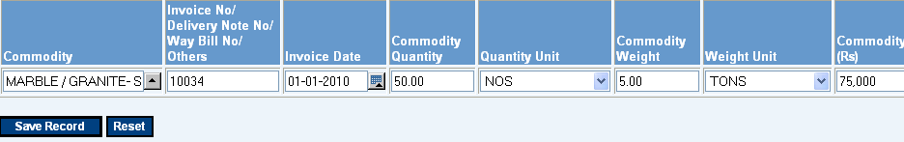

1 | Commodity | This is a selection field. Select from the list.
2 | Invoice No | This is an entry field. Enter the Invoice No.
3 | Invoice Date | This is an entry / selection field. Enter the Invoice date in dd/mm/yyyy format or select from the calendar.
4 | Quantity | This is an entry field. Enter the Quantity.
5 | Quantity Unit | This is a selection field. Select from the list.  (Numbers / Tins etc)
6 | Wight | This is an entry field. Enter the Weight.
7 | Weight Unit | This is a selection field. Select from the list.  (Liters /Tons etc)
8 | Value | This is an entry field. Enter the Value.

Note:

- Multiple commodities can be entered by clicking the option ADD ROW. Click the option REMOVE ROW to delete any commodities.
- While saving, system prompts “Whether you want to enter another transaction”. Press YES if the vehicle have multiple consignments. If not press NO to stop the process.

After completion, TOKEN is generated with unique TOKEN NO.

Please note the TOKEN NO and VEHICLE NO for any further follow-ups like Modify / Print purpose.

2. Modify Declaration

The following screen appears on clicking the link Modify.

Enter both Token Number and Vehicle Number to fetch the exact data.

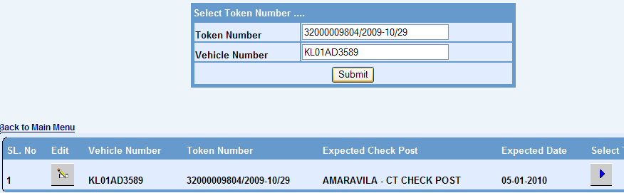

On clicking the edit option, vehicle details can be modified.

On clicking the Select option, all consignments would be listed. Click edit option to modify any consignment / commodity details.

2. Print Declaration

The following screen appears on clicking the link Print.

Enter both Token Number and Vehicle Number to fetch the exact data.

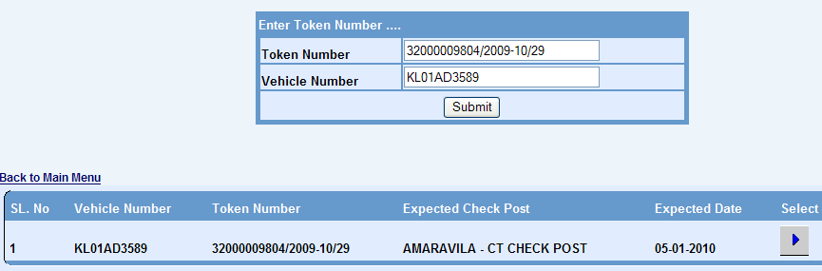

On clicking the Select option, the e-Consignment Declaration would be displayed.

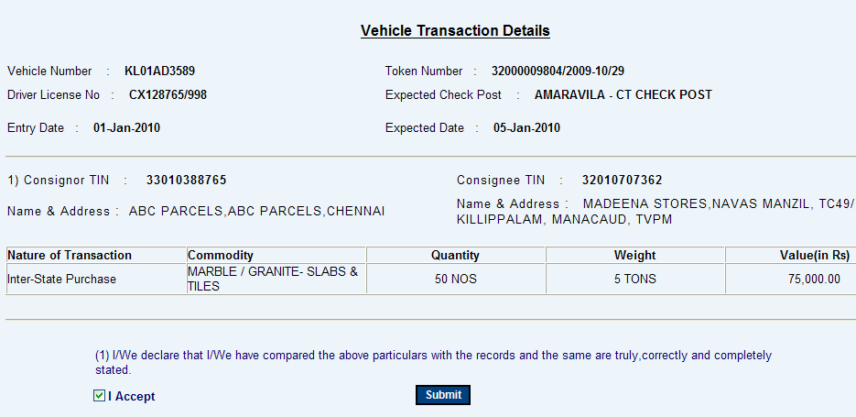

Select the option “I Accept”, and press SUBMIT to Print the e-Consignment Declaration.

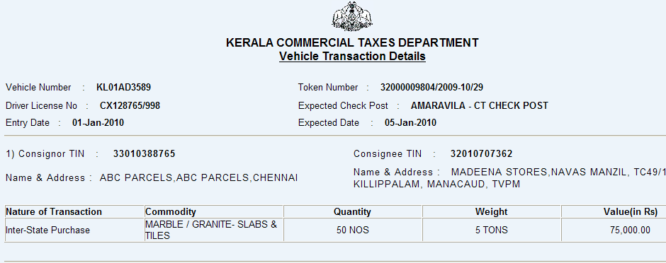

Please Note:

- Print the e-Consignment Declaration and carry along with the vehicle.

- Once the vehicle reached the checkpost, produce the declaration print out to the checkpost officials for verification.

- After verification, checkpost officials will upload the data into KVATIS.

- Please contact the phone nos / emails (available in the home page) for any help from Kerala Commercial Taxes Department.

Thank You..

